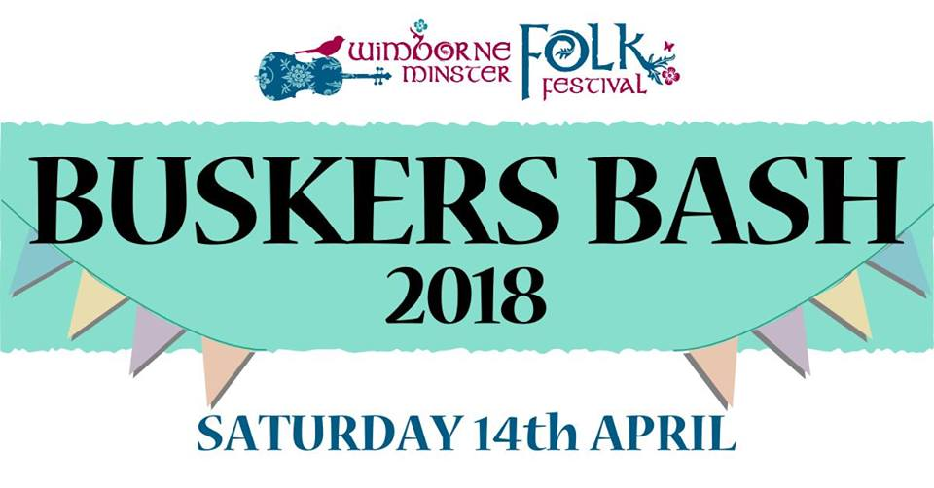

The Green Man Lineup!
11.30am - Ekko Handpan
12.00pm - Solyd
12.30pm - Gordon Wray
1.00pm - Steve Faulkner
1.30pm - Klauss
2.00pm - Ellie et al
2.30pm - Wenzi
3.00pm - Inner City Smugglers
3.30pm - Choppers Children
4.00pm - Alex
4.30pm - Men with No Name

Buskers Bash Finals from 5.45pm

Everyone welcome, please come along and support your favourite musician!

